UNIT-5

Application Layer

5.1 Domain Name System (DNS)
DNS is a hostname for IP address translation service. DNS is a distributed database implemented in a hierarchy of name servers. It is an application layer protocol for message exchange between clients and servers.
Requirement: Every host is identified by the IP address but remembering numbers is very difficult for the people also the IP addresses are not static therefore a mapping is required to change the domain name to the IP address. So DNS is used to convert the domain name of the websites to their numerical IP address.

Domain: There are various kinds of DOMAIN:
- Generic domain: .com(commercial) .edu(educational) .mil(military) .org(non profit organization) .net(similar to commercial) all these are generic domain.
- Country domain .in (india) .us .uk
- Inverse domain if we want to know what is the domain name of the website. Ip to domain name mapping. So DNS can provide both the mapping for example to find the ip addresses of geeksforgeeks.org then we have to type nslookup www.geeksforgeeks.org.

Organization of Domain: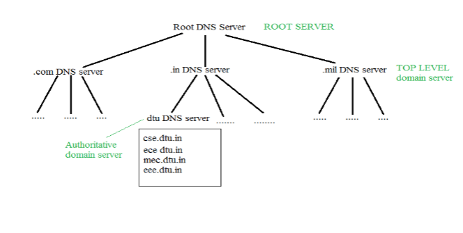
It is very difficult to find out the ip address associated to a website because there are millions of websites and with all those websites we should be able to generate the ip address immediately, there should not be a lot of delay for that to happen organization of database is very important.
DNS record: Domain name, ip address what is the validity?? what is the time to live ?? and all the information related to that domain name. These records are stored in tree like structure.
Namespace: Set of possible names, flat or hierarchical. The naming system maintains a collection of bindings of names to values – given a name, a resolution mechanism returns the corresponding value.
Name server: It is an implementation of the resolution mechanism. DNS (Domain Name System) = Name service in Internet – Zone is an administrative unit, domain is a subtree.
Name to Address Resolution: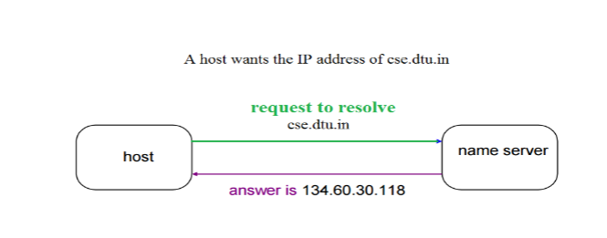
The host requests the DNS name server to resolve the domain name. And the name server returns the IP address corresponding to that domain name to the host so that the host can future connect to that IP address.
Hierarchy of Name Servers Root name servers: It is contacted by name servers that can not resolve the name. It contacts authoritative name server if name mapping is not known. It then gets the mapping and returns the IP address to the host.
Top level domain (TLD) server: It is responsible for com, org, edu etc and all top level country domains like uk, fr, ca, in etc. They have info about authoritative domain servers and know the names and IP addresses of each authoritative name server for the second-level domains.
Authoritative name servers are the organization’s DNS server, providing authoritative hostName to IP mapping for organization servers. It can be maintained by an organization or service provider. In order to reach cse.dtu.in we have to ask the root DNS server, then it will point out to the top level domain server and then to authoritative domain name server which actually contains the IP address. So the authoritative domain server will return the associative ip address.
Domain Name Server
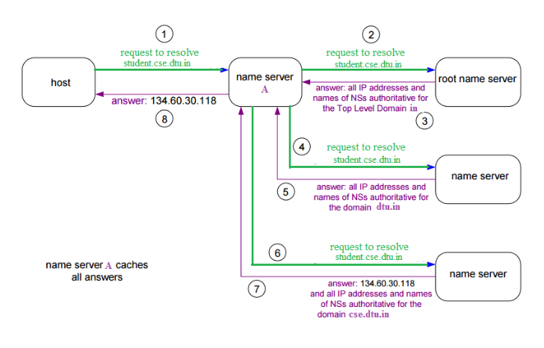
The client machine sends a request to the local name server, which , if root does not find the address in its database, sends a request to the root name server , which in turn, will route the query to an top-level domain (TLD) or authoritative name server. The root name server can also contain some hostName to IP address mappings. The Top-level domain (TLD) server always knows who the authoritative name server is. So finally the IP address is returned to the local name server which in turn returns the IP address to the host.

What is a DNS record?
DNS records (aka zone files) are instructions that live in authoritative DNS servers and provide information about a domain including what IP address is associated with that domain and how to handle requests for that domain. These records consist of a series of text files written in what is known as DNS syntax. DNS syntax is just a string of characters used as commands that tell the DNS server what to do. All DNS records also have a ‘TTL’, which stands for time-to-live, and indicates how often a DNS server will refresh that record.
You can think of a set of DNS records like a business listing on Yelp. That listing will give you a bunch of useful information about a business such as their location, hours, services offered, etc. All domains are required to have at least a few essential DNS records for a user to be able to access their website using a domain name, and there are several optional records that serve additional purposes.

What are the most common types of DNS record?
- A record - The record that holds the IP address of a domain. Learn more about the A record.
- AAAA record - The record that contains the IPv6 address for a domain (as opposed to A records, which list the IPv4 address). Learn more about the AAAA record.
- CNAME record - Forwards one domain or subdomain to another domain, does NOT provide an IP address. Learn more about the CNAME record.
- MX record - Directs mail to an email server. Learn more about the MX record.
- TXT record - Lets an admin store text notes in the record. These records are often used for email security. Learn more about the TXT record.
- NS record - Stores the name server for a DNS entry. Learn more about the NS record.
- SOA record - Stores admin information about a domain. Learn more about the SOA record.
- SRV record - Specifies a port for specific services. Learn more about the SRV record.
- PTR record - Provides a domain name in reverse-lookups. Learn more about the PTR record.
Electronic Mail (e-mail) is one of most widely used services of Internet. This service allows an Internet user to send a message in formatted manner (mail) to the other Internet user in any part of world. Message in mail not only contain text, but it also contains images, audio and videos data. The person who is sending mail is called sender and person who receives mail is called recipient. It is just like postal mail service. Components of E-Mail System : The basic components of an email system are : User Agent (UA), Message Transfer Agent (MTA), Mail Box, and Spool file. These are explained as following below.
- User Agent (UA) : The UA is normally a program which is used to send and receive mail. Sometimes, it is called as mail reader. It accepts variety of commands for composing, receiving and replying to messages as well as for manipulation of the mailboxes.
- Message Transfer Agent (MTA) : MTA is actually responsible for transfer of mail from one system to another. To send a mail, a system must have client MTA and system MTA. It transfer mail to mailboxes of recipients if they are connected in the same machine. It delivers mail to peer MTA if destination mailbox is in another machine. The delivery from one MTA to another MTA is done by Simple Mail Transfer Protocol. 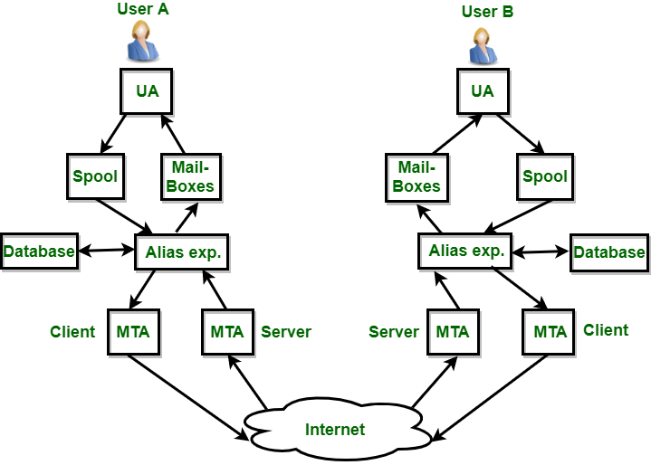
- Mailbox : It is a file on local hard drive to collect mails. Delivered mails are present in this file. The user can read it delete it according to his/her requirement. To use e-mail system each user must have a mailbox . Access to mailbox is only to owner of mailbox.
- Spool file : This file contains mails that are to be sent. User agent appends outgoing mails in this file using SMTP. MTA extracts pending mail from spool file for their delivery. E-mail allows one name, an alias, to represent several different e-mail addresses. It is known as mailing list, Whenever user have to sent a message, system checks recipient’s name against alias database. If mailing list is present for defined alias, separate messages, one for each entry in the list, must be prepared and handed to MTA. If for defined alias, there is no such mailing list is present, name itself becomes naming address and a single message is delivered to mail transfer entity.
Services provided by E-mail system :
- Composition – The composition refer to process that creates messages and answers. For composition any kind of text editor can be used.
- Transfer – Transfer means sending procedure of mail i.e. from the sender to recipient.
- Reporting – Reporting refers to confirmation for delivery of mail. It help user to check whether their mail is delivered, lost or rejected.
- Displaying – It refers to present mail in form that is understand by the user.
- Disposition – This step concern with recipient that what will recipient do after receiving mail i.e save mail, delete before reading or delete after reading.

Introduction
Electronic mail (e-mail) is a computer-based program that allows users to send and receive messages. E-mail is the electronic version of a letter, but with time and flexibility advantages. While a letter can take anywhere from a week to a couple of months to reach its intended destination, an e-mail is sent virtually almost instantly.
Messages in the mail contain not just text but also photos, audio, and video data. A person sending an e-mail is a sender, and the person receiving it is the recipient.

What is Electronic Mail in Computer Networks?
Electronic mail is one of the most well-known network services. Electronic mail is a computer-based service that allows users to communicate with one another by exchanging messages. Email information is transmitted via email servers and uses a variety of TCP/IP protocols. For example, the simple mail transfer protocol (SMTP) is a protocol that is used to send messages. Similarly, IMAP or POP receives messages from a mail server.

Features Of Electronic Mail
- Spontaneity: In a couple of seconds, you may send a message to anybody on the globe.
- Asynchronous: You may send the e-mail and let the recipient view it at their leisure.
- Attachments of data, pictures, or music, frequently in compressed forms, can be delivered as an e-mail to a person anywhere in the world.
- Addresses can be stored in an address book and retrieved instantly.
- Through an e-mail, a user can transfer multiple copies of a message to various individuals.

Services offered by Electronic Mail
Composition: Creating messages and responses is referred to as composition.
Transfer: Sending mail from the sender to the receiver is known as a transfer.
Reporting: Mail delivery confirmation is known as reporting. It allows users to see if
their mail has been delivered, misplaced, or rejected.
Displaying: It refers to presenting messages so that the user can understand them.
Disposition: This stage concerns the recipient's actions after receiving mail, such as saving it, deleting it before reading it, or after reading it.
(Also see SMTP)

Components Of Electronic Mail
The following are the essential components of an e-mail system:
- User Agent (UA)
- Message Transfer Agent (MTA)
- Message Access Agent
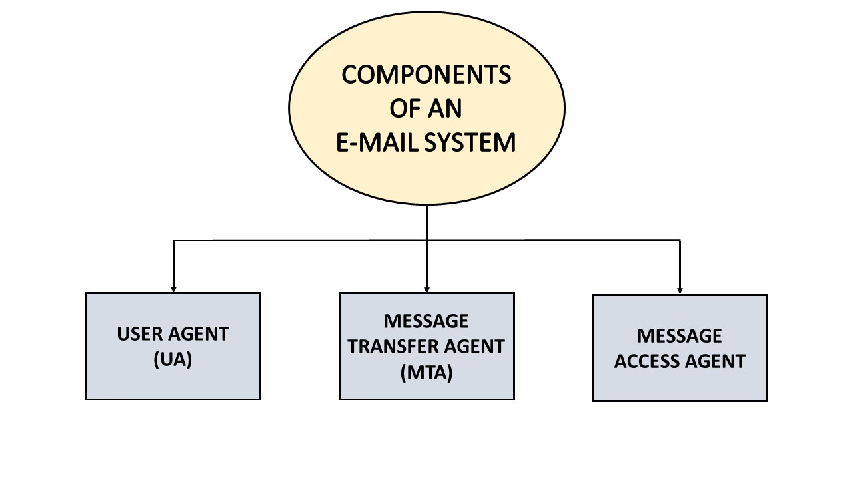

User Agent (UA)
The User-Agent is a simple software that sends and receives mail. It is also known as a mail reader. It supports a wide range of instructions for sending, receiving, and replying to messages and manipulating mailboxes.
Some of the services supplied by the User-Agent are listed below:
- Reading a Message
- Sending a reply to a Message
- Message Composition
- Forwarding a Message
- Handling the Message

Message Transfer Agent
The Message Transfer Agent manages the actual e-mail transfer operation (MTA). Simple Mail Transfer Protocol sends messages from one MTA to another. A system must have a client MTA and a system MTA to send an e-mail. If the recipients are connected to the same computer, it sends mail to their mailboxes. If the destination mailbox is on another computer, it sends mail to the receiver's MTA.

Message Access Agent
The Simple Mail Transfer Protocol is used for the first and second stages of e-mail delivery.
The pull protocol is mainly required at the third stage of e-mail delivery, and the message access agent is used at this point.
POP and IMAP4 are the two protocols used to access messages.

Architecture of Electronic Mail
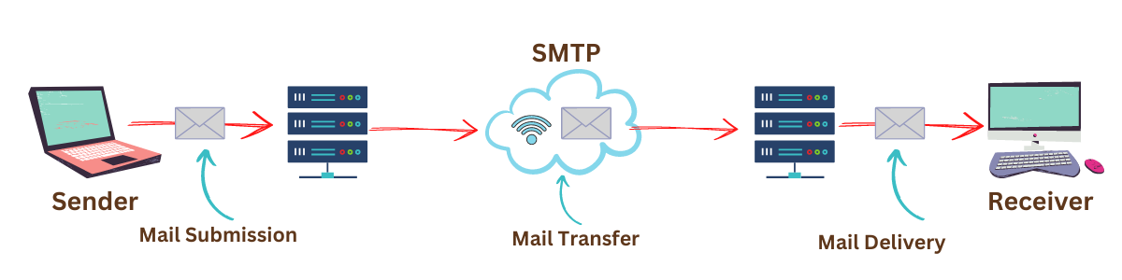

First Scenario
In the first scenario, two user agents are required. The sender and recipient of the e-mail share the same machine directly connected to the server.
For example, let us consider two user agents, Ninja1 and Ninja2. When Ninja1 sends an e-mail to Ninja2, the user agent (UA) programme is used to prepare the message. Following that, this e-mail gets saved in the Ninja2 inbox.
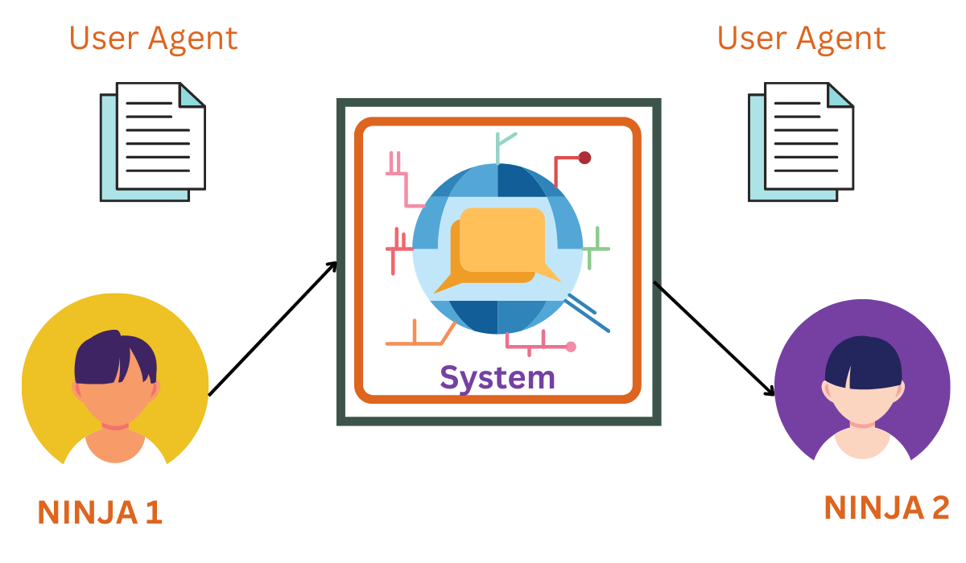

Second Scenario
In this case, the sender and recipient of an e-mail are essentially users on two different machines over the internet. User-Agents and Message Transfer Agents(MTA) are required in this scenario.
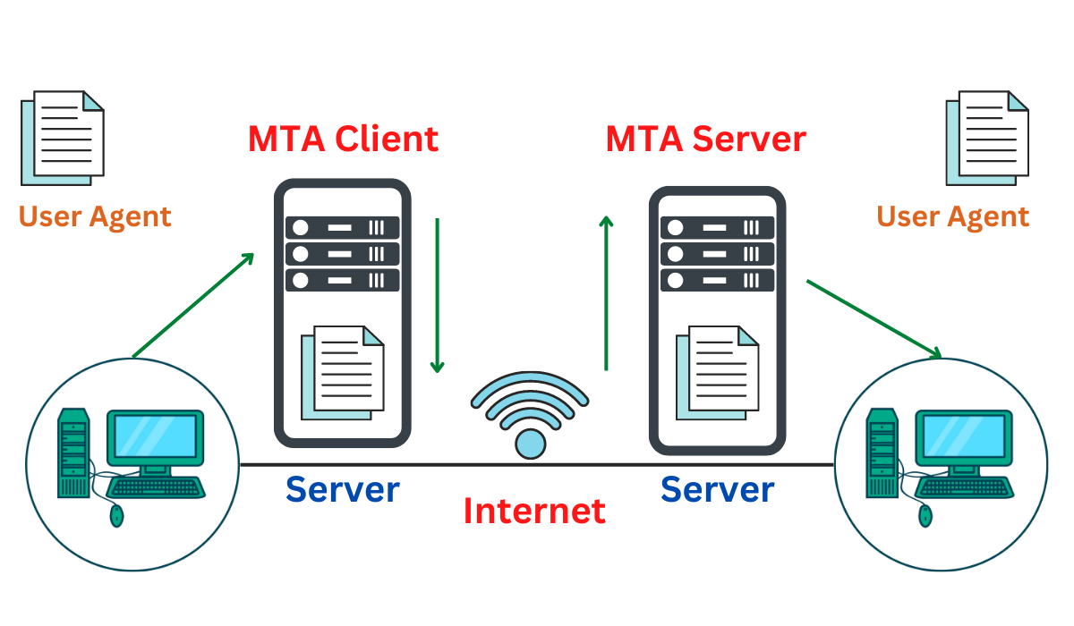
Take, for example, two user agents (Ninja1 and Ninja2), as illustrated in the diagram. When Ninja1 sends an e-mail to Ninja2, the user agent (UA) and message transfer agents (MTAs) programmes prepare the e-mail for transmission over the internet. Following that, this e-mail gets stored in Ninja2's inbox.

Third Scenario
The sender is connected to the system by a point-to-point WAN, which can be a dial-up modem or a cable modem in this case. On the other hand, the receiver is directly attached to the system, as it was in the second scenario.
The sender also needs a User agent (UA) to prepare the message in this situation. After preparing the statement, the sender delivers it over LAN or WAN via a pair of MTAs.
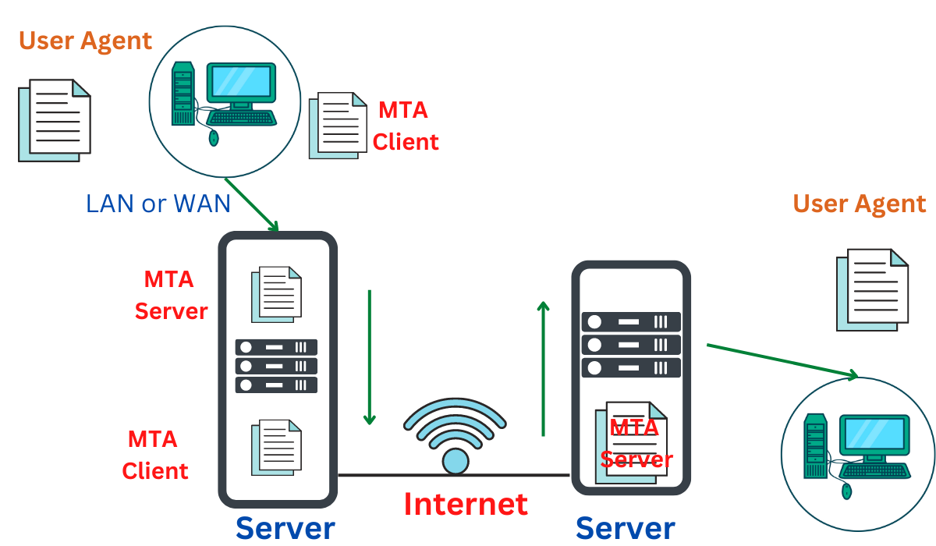

Fourth Scenario
In this scenario, the recipient is linked to the mail server via WAN or LAN. When the message arrives, the recipient must retrieve it, which needs additional client/server agents. This scenario requires two user agents (UAs), two pairs of message transfer agents (MTAs), and a couple of message access agents (MAAs).
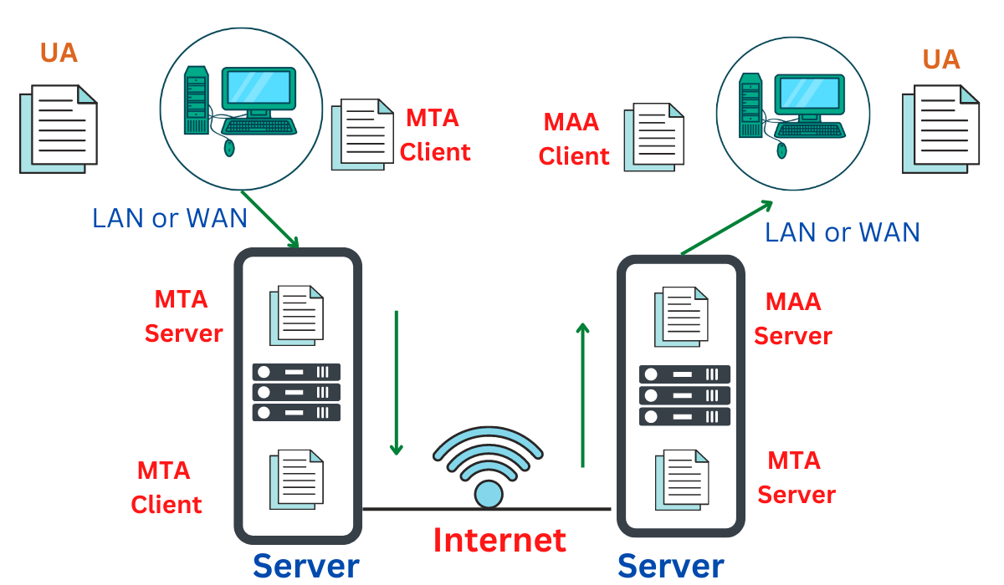

Frequently Asked Questions

What is Electronic Mail in Computer Networks?
One of the most well-known network services is electronic mail. A computer-based service called electronic mail enables users to exchange messages with one another to communicate. Usually, it involves sending data saved on a computer through a network to a specific person or group of people.

What is Electronic Mail used for?
Computer users on a network can transmit text, images, sounds, and animations to one another via an e-mail system. Email systems are a crucial communication channel between employees and authorities to access large institutions' networks. Many public online systems, which maintain free worldwide communication, also offer e-mail access.

What are the advantages of electronic mail in computer networks?
Some advantages of using electronic email are Mass Sending, Cost-effective, and Advertising. Using Mass sending A user may quickly send a message to many individuals. Email is a low-cost method of communicating with people. Emails are useful for product promotion as businesses can communicate in a short period of time.

Electronic Mail (e-mail) is one of the most widely used services of the Internet. This service allows an Internet user to send a message in a formatted manner (mail) to other Internet users in any part of the world. Message in the mail not only contain text, but it also contains images, audio and videos data. The person who is sending mail is called sender and person who receives mail is called the recipient. It is just like postal mail service.
Format of E-mail :
An e-mail consists of three parts that are as follows :
1. Envelope
2. Header
3. Body
These are explained as following below.
1. Envelope :
The envelope part encapsulates the message. It contains all information that is required for sending any e-mail such as destination address, priority and security level. The envelope is used by MTAs for routing message.
2. Header :
The header consists of a series of lines. Each header field consists of a single line of ASCII text specifying field name, colon and value. The main header fields related to message transport are :
- To: It specifies the DNS address of the primary recipient(s).
- Cc : It refers to carbon copy. It specifies address of secondary recipient(s).
- BCC: It refers to blind carbon copy. It is very similar to Cc. The only difference between Cc and Bcc is that it allow user to send copy to the third party without primary and secondary recipient knowing about this.
- From : It specifies name of person who wrote message.
- Sender : It specifies e-mail address of person who has sent message.
- Received : It refers to identity of sender’s, data and also time message was received. It also contains the information which is used to find bugs in routing system.
- Return-Path: It is added by the message transfer agent. This part is used to specify how to get back to the sender.
3. Body:- The body of a message contains text that is the actual content/message that needs to be sent, such as “Employees who are eligible for the new health care program should contact their supervisors by next Friday if they want to switch.” The message body also may include signatures or automatically generated text that is inserted by the sender’s email system.
The above-discussed field is represented in tabular form as follows :
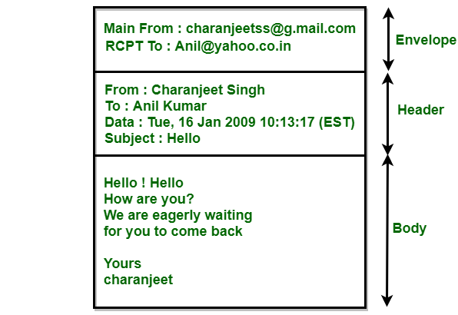
Header | Meaning
To: | E-mail address of primary receipt(s).
Cc: | E-mail address of secondary receipt(s).
Bcc: | E-mail address for blind carbon copies.
From: | Person or people who have created a message.
Sender: | E-mail address of the actual sender.
Received: | It is used to specify how to get back to the sender.
Return-Path | It can be used to identify a path back to the sender.
In addition to above-discussed fields, the header may also contain a variety of other fields which are as follows :
Header | Meaning
Date: | Date and time when the message was sent.
Reply-To: | It contains e-mail address to which replies should be sent.
Message-Id: | It refers to the unique number for referencing this message later.
In-Reply-To: | Message-Id of a message to which this is as a reply.
References: | It contains other relevant message-ids.
Keywords: | User-chosen keywords.
Subject: | It contains short summary of message for one-line display.

Streaming of videos involve, storing of prerecorded videos on servers.
- Users send request to those servers.
- Users may watch the video from the start till the end, and may pause it anytime, do a forward or reverse skip, or stop the video whenever they want to do so.
There are 3 video streaming categories:
1. UDP Streaming
2. HTTP Streaming
3. Adaptive HTTP Streaming
Usually, today’s system employs HTTP and Adaptive HTTP Streaming.
Common characteristic of these three streaming technique is that the extensive use of Client-Side Buffering.
Advantages of Client Buffering:
- Client side buffer absorbs variations in server-client delay. Until the delayed packet is received by the client, the received-but not yet-played video will be played.
- Even if bandwidth drops, user can view the video until the buffer is completely drained.
1. UDP STREAMING:
UDP servers send video chunks (Chunk: unit of information that contains either control information or user data) to clients, based on client’s consumption rate. It transmits chunks at a rate, that matches client’s video consumption rate by clocking out video chunks over UDP over steady state.
For example,
Video consumption rate = 2Mbps
Capacity of one UDP packet = 8000 bits

Therefore,
Transmission rate = 8000 bits/2 Mbps = 4000 msec
Properties:
- UDP does not use congestion-control mechanism. Video chunks are encapsulated before transmission using RTT (Real-Time Transport) Protocol.
- Additional client-server path is maintained to inform the client state to server like pause, resume, skip and so on.
Drawbacks:
- Bandwidth is unpredictable and varying between client and server.
- UDP streaming requires a separate media control server like RTSP server(Real-Time Streaming Protocol) to track client state(pause, resume etc).
- Devices are configured with firewalls to block UDP traffic which prevents the reception of UDP packets to clients.
2. HTTP STREAMING:
Video is stored in an HTTP server as a simple ordinary file with a unique URL. Client establishes TCP connection with server and issues a HTTP GET request for that URL. Server sends the video file along with an HTTP RESPONSE. Now the client buffer grabs the video and then displayed on user screen.
Advantages:
- Use of HTTP over TCP allows the video to traverse firewalls and NATs easily.
- Does not need any media control servers like RTSP servers causing reduction in cost of large-scale deployment over internet.
Disadvantages:
• Latency or lag between a video is recorded and played. This can make the viewers more annoyed and irritated. Only a few milliseconds delay is acceptable.
• Early pre-fetching of video, but, what if, the user stops playing the video at a early stage? Wastage of data is not appreciated.
• All clients receive the same encoding of the video, despite the large variations in bandwidth amount available to different clients and also for same client over time.
Uses:
Youtube and Netflix uses HTTP streaming mechanism.
3. ADAPTIVE HTTP STREAMING:
The major drawbacks of HTTP streaming, lead to development of new type of HTTP based streaming referred to as DASH (Dynamic Adaptive Streaming over HTTP). Videos are encoded into different bit rate versions, having different quality. The host makes a dynamic video request of few seconds in length from different bit versions. When bandwidth is high, high bit rate chunks are received hence high quality similarly, low quality video during low bandwidth.
Advantages:
- DASH uses the user to switch over different qualities of video on screen.
- Client can use HTTP byte-range request to precisely control the amount of pre-fetched video that is locally buffered.
- DASH also stores the audio in different versions with different quality and different bit-rate with unique URL.
So the client dynamically selects the video and audio chunks and synchronizes it locally in the play-out.
Uses:
COMCAST uses DASH for streaming high quality video contents.

INTRODUCTION
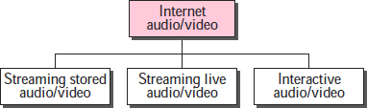
We can divide audio and video services into three broad categories: streaming stored audio/video, streaming live audio/video, and interactive audio/video. Streaming means a user can listen (or watch) the file after the downloading has started.
In the first category, streaming stored audio/video, the files are compressed and stored on a server. A client downloads the files through the Internet. This is sometimes referred to as on-demand audio/video. In the second category, streaming live audio/video refers to the broadcasting of radio and TV programs through the Internet. In the third category, interactive audio/video refers to the use of the Internet for interactive audio/video applications. A good example of this application is Internet telephony and Internet teleconferencing.

STREAMING STORED AUDIO/VIDEO
Downloading these types of files from a server can be different from downloading other types of files.

First Approach: Using a Web Server
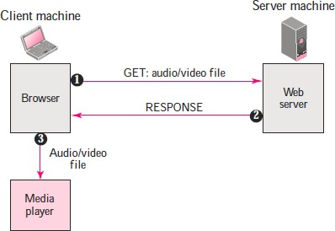
A compressed audio/video file can be downloaded as a text file. The client (browser) can use the services of HTTP and send a GET message to download the file. The Web server can send the compressed file to the browser. The browser can then use a help application, normally called a media player, to play the file. The file needs to download completely before it can be played.

Second Approach: Using a Web Server with Metafile
In another approach, the media player is directly connected to the Web server for downloading the audio/video file. The Web server stores two files: the actual audio/video file and a metafile that holds information about the audio/video file.
    - The HTTP client accesses the Web server using the GET message.
    - The information about the metafile comes in the response.
    - The metafile is passed to the media player.
    - The media player uses the URL in the metafile to access the audio/video file.
    - The Web server responds.

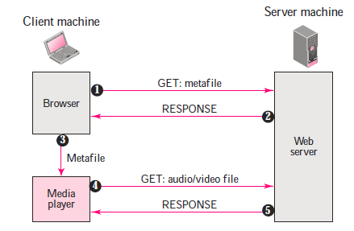
Third Approach: Using a Media Server
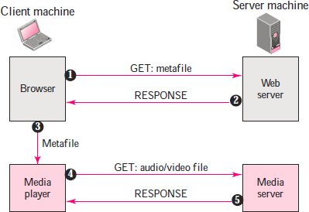
The problem with the second approach is that the browser and the media player both use the services of HTTP. HTTP is designed to run over TCP. This is appropriate for retrieving the metafile, but not for retrieving the audio/video file. The reason is that TCP retransmits a lost or damaged segment, which is counter to the philosophy of streaming. We need to dismiss TCP and its error control; we need to use UDP. However, HTTP, which accesses the Web server, and the Web server itself are designed for TCP; we need another server, a media server.
    - The HTTP client accesses the Web server using a GET message.
    - The information about the metafile comes in the response.
    - The metafile is passed to the media player.
    - The media player uses the URL in the metafile to access the media server to download the file. Downloading can take place by any protocol that uses UDP.
    - The media server responds.

Fourth Approach: Using a Media Server and RTSP
The Real-Time Streaming Protocol (RTSP) is a control protocol designed to add more functionalities to the streaming process. Using RTSP, we can control the playing of audio/video. Figure 5 shows a media server and RTSP.
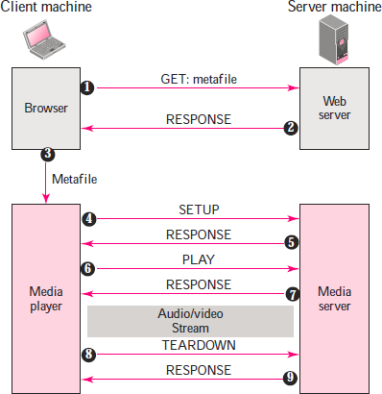

    - The HTTP client accesses the Web server using a GET message.
    - The information about the metafile comes in the response.
    - The metafile is passed to the media player.
    - The media player sends a SETUP message to create a connection with the media server.
    - The media server responds.
    - The media player sends a PLAY message to start playing (downloading).
    - The audio/video file is downloaded using another protocol that runs over UDP.
    - The connection is broken using the TEARDOWN message.
    - The media server responds.

STREAMING LIVE AUDIO/VIDEO
Streaming live audio/video is similar to the broadcasting of audio and video by radio and TV stations. Instead of broadcasting to the air, the stations broadcast through the Internet. There are several similarities between streaming stored audio/video and streaming live audio/video. They are both sensitive to delay; neither can accept retransmission. However, there is a difference. In the first application, the communication is unicast and on-demand. In the second, the communication is multicast and live. Live streaming is better suited to the multicast services of IP and the use of protocols such as UDP and RTP.
Examples: Internet Radio, Internet Television (ITV), Internet protocol television (IPTV)

REAL-TIME INTERACTIVE AUDIO/VIDEO
In real-time interactive audio/video, people communicate with one another in real time. The Internet phone or voice over IP is an example of this type of application. Video conferencing is another example that allows people to communicate visually and orally.
Before discussing the protocols used in this class of applications, we discuss some characteristics of real-time audio/video communication.

Time Relationship
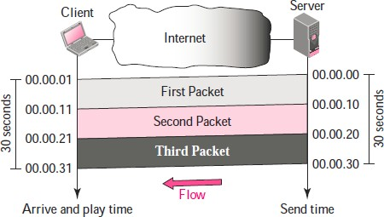
Real-time data on a packet-switched network require the preservation of the time relationship between packets of a session.

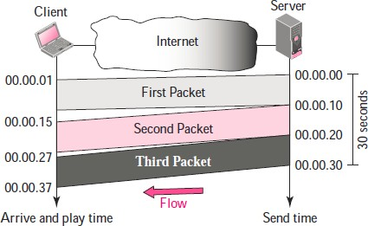
But what happens if the packets arrive with different delays? For example, the first packet arrives at 00:00:01 (1-s delay), the second arrives at 00:00:15 (5-s delay), and the third arrives at 00:00:27 (7-s delay). If the receiver starts playing the first packet at 00:00:01, it will finish at 00:00:11. However, the next packet has not yet arrived; it arrives 4 s later. There is a gap between the first and second packets and between the second and the third as the video is viewed at the remote site. This phenomenon is called jitter. Jitter is introduced in real-time data by the delay between packets.

Timestamp
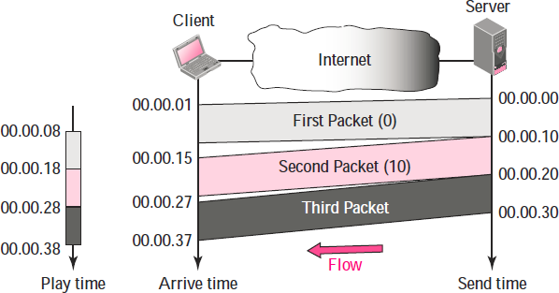
One solution to jitter is the use of a timestamp. If each packet has a timestamp that shows the time it was produced relative to the first (or previous) packet, then the receiver can add this time to the time at which it starts the playback. Imagine the first packet in the previous example has a timestamp of 0, the second has a timestamp of 10, and the third a timestamp of 20. If the receiver starts playing back the first packet at 00:00:08, the second will be played at 00:00:18, and the third at 00:00:28. There are no gaps between the packets.

Playback Buffer
To be able to separate the arrival time from the playback time, we need a buffer to store the data until they are played back. The buffer is referred to as a playback buffer. In the previous example, the first bit of the first packet arrives at 00:00:01; the threshold is 7 s, and the playback time is 00:00:08. The threshold is measured in time units of data. The replay does not start until the time units of data are equal to the threshold value.
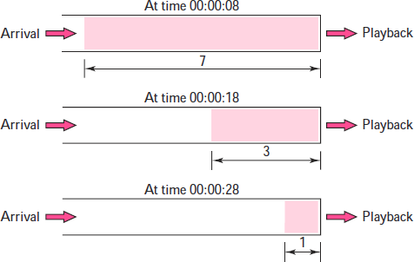

Ordering
We need a sequence number for each packet. The timestamp alone cannot inform the receiver if a packet is lost.

Multicasting
Multimedia play a primary role in audio and video conferencing. The traffic can be heavy, and the data are distributed using multicasting methods. Conferencing requires two-way communication between receivers and senders.

Mixing
If there is more than one source that can send data at the same time (as in a video or audio conference), the traffic is made of multiple streams. Mixing means combining several streams of traffic into one stream.

- Support from Transport Layer Protocol
TCP is not suitable for interactive traffic. It has no provision for timestamping, and it does not support multicasting. However, it does provide ordering (sequence numbers). One feature of TCP that makes it particularly unsuitable for interactive traffic is its error control mechanism.
UDP is more suitable for interactive multimedia traffic. UDP supports multicasting and has no retransmission strategy. However, UDP has no provision for timestamping, sequencing, or mixing. A new transport protocol, Real-Time Transport Protocol (RTP), provides these missing features.

Real-time Transport Protocol (RTP)
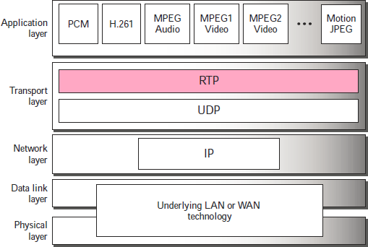
Real-time Transport Protocol (RTP) is the protocol designed to handle real-time traffic on the Internet. RTP does not have a delivery mechanism (multicasting, port numbers, and so on); it must be used with UDP. RTP stands between UDP and the application program. The main contributions of RTP are timestamping, sequencing, and mixing facilities.

RTP Packet Format
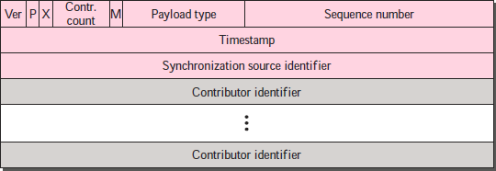
The format is very simple and general enough to cover all real-time applications. An application that needs more information adds it to the beginning of its payload. A description of each field follows.
- Ver. This 2-bit field defines the version number.
- P. This 1-bit field, if set to 1, indicates the presence of padding at the end of the packet. There is no padding if the value of the P field is 0.
- X. This 1-bit field, if set to 1, indicates an extra extension header between the basic header and the data. There is no extra extension header if the value of this field is 0.
- Contributor count. This 4-bit field indicates the number of contributors. Note that we can have a maximum of 15 contributors because a 4-bit field only allows a number between 0 and 15.
- M. This 1-bit field is a marker used by the application to indicate, for example, the end of its data.
- Payload type. This 7-bit field indicates the type of the payload. Several payload types have been defined so far.
- Sequence number. This field is 16 bits in length. It is used to number the RTP packets. The sequence number of the first packet is chosen randomly; it is incremented by 1 for each subsequent packet. The sequence number is used by the receiver to detect lost or out of order packets.
- Timestamp. This is a 32-bit field that indicates the time relationship between packets.
- Synchronization source identifier. If there is only one source, this 32-bit field defines the source. However, if there are several sources, the mixer is the synchronization source and the other sources are contributors. The value of the source identifier is a random number chosen by the source. The protocol provides a strategy in case of conflict (two sources start with the same sequence number).
- Contributor identifier. Each of these 32-bit identifiers (a maximum of 15) defines a source. When there is more than one source in a session, the mixer is the synchronization source and the remaining sources are the contributors.

UDP Port
Although RTP is itself a transport layer protocol, the RTP packet is not encapsulated directly in an IP datagram. Instead, RTP is treated like an application program and is encapsulated in a UDP user datagram. However, unlike other application programs, no well-known port is assigned to RTP. The port can be selected on demand with only one restriction: The port number must be an even number. The next number (an odd number) is used by the companion of RTP, Real-Time Transport Control Protocol (RTCP).

Real-Time Transport Control Protocol (RTCP)
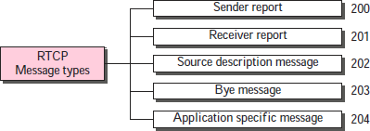
RTP allows only one type of message, one that carries data from the source to the destination. In many cases, there is a need for other messages in a session. These messages control the flow and quality of data and allow the recipient to send feedback to the source or sources. Real-Time Transport Control Protocol (RTCP) is a protocol designed for this purpose. RTCP has five types of messages, as shown in the following Figure. The number next to each box defines the type of the message.

Types of messages

- Sender Report:
The sender report is sent periodically by the active senders in a conference to report transmission and reception statistics for all RTP packets sent during the interval.
- Receiver Report:
The receiver report is for passive participants, those that do not send RTP packets. The report informs the sender and other receivers about the quality of service.
- Source Description Message:
The source periodically sends a source description message to give additional information about itself.
- Bye Message:
A source sends a bye message to shut down a stream. It allows the source to announce that it is leaving the conference.
- Application-Specific Message
The application-specific message is a packet for an application that wants to use new applications (not defined in the standard). It allows the definition of a new message type.

UDP Port
RTCP, like RTP, does not use a well-known UDP port. It uses a temporary port. The UDP port chosen must be the number immediately following the UDP port selected for RTP, which makes it an odd-numbered port.

- VOICE OVER IP (Real-time interactive audio/video application)
The idea is to use the Internet as a telephone network with some additional capabilities. Instead of communicating over a circuit-switched network, this application allows communication between two parties over the packet-switched Internet. Two protocols have been designed to handle this type of communication: SIP(Session Initiation Protocol) and H.323.

Content Delivery Networks

A content delivery network (CDN) refers to a geographically distributed group of servers which work together to provide fast delivery of Internet content.
A CDN allows for the quick transfer of assets needed for loading Internet content including HTML pages, javascript files, stylesheets, images, and videos. The popularity of CDN services continues to grow, and today the majority of web traffic is served through CDNs, including traffic from major sites like Facebook, Netflix, and Amazon.
A properly configured CDN may also help protect websites against some common malicious attacks, such as Distributed Denial of Service (DDOS) attacks.

Is a CDN the same as a web host?
While a CDN does not host content and can’t replace the need for proper web hosting, it does help cache content at the network edge, which improves website performance. Many websites struggle to have their performance needs met by traditional hosting services, which is why they opt for CDNs.
By utilizing caching to reduce hosting bandwidth, helping to prevent interruptions in service, and improving security, CDNs are a popular choice to relieve some of the major pain points that come with traditional web hosting.

What are the benefits of using a CDN?
Although the benefits of using a CDN vary depending on the size and needs of an Internet property, the primary benefits for most users can be broken down into 4 different components:
- Improving website load times - By distributing content closer to website visitors by using a nearby CDN server (among other optimizations), visitors experience faster page loading times. As visitors are more inclined to click away from a slow-loading site, a CDN can reduce bounce rates and increase the amount of time that people spend on the site. In other words, a faster a website means more visitors will stay and stick around longer.
- Reducing bandwidth costs - Bandwidth consumption costs for website hosting is a primary expense for websites. Through caching and other optimizations, CDNs are able to reduce the amount of data an origin server must provide, thus reducing hosting costs for website owners.
- Increasing content availability and redundancy - Large amounts of traffic or hardware failures can interrupt normal website function. Thanks to their distributed nature, a CDN can handle more traffic and withstand hardware failure better than many origin servers.
- Improving website security - A CDN may improve security by providing DDoS mitigation, improvements to security certificates, and other optimizations.

How does a CDN work?
At its core, a CDN is a network of servers linked together with the goal of delivering content as quickly, cheaply, reliably, and securely as possible. In order to improve speed and connectivity, a CDN will place servers at the exchange points between different networks.
These Internet exchange points (IXPs) are the primary locations where different Internet providers connect in order to provide each other access to traffic originating on their different networks. By having a connection to these high speed and highly interconnected locations, a CDN provider is able to reduce costs and transit times in high speed data delivery.

Beyond placement of servers in IXPs, a CDN makes a number of optimizations on standard client/server data transfers. CDNs place Data Centers at strategic locations across the globe, enhance security, and are designed to survive various types of failures and Internet congestion.

Latency - How does a CDN improve website load times?
When it comes to websites loading content, users drop off quickly as a site slows down. CDN services can help to reduce load times in the following ways:
- The globally distributed nature of a CDN means reduce distance between users and website resources. Instead of having to connect to wherever a website’s origin server may live, a CDN lets users connect to a geographically closer data center. Less travel time means faster service.
- Hardware and software optimizations such as efficient load balancing and solid-state hard drives can help data reach the user faster.
- CDNs can reduce the amount of data that’s transferred by reducing file sizes using tactics such as minification and file compression. Smaller file sizes mean quicker load times.
- CDNs can also speed up sites which use TLS/SSL certificates by optimizing connection reuse and enabling TLS false start.
Explore all the ways a CDN helps websites load faster

Reliability and Redundancy - How does a CDN keep a website always online?
Uptime is a critical component for anyone with an Internet property. Hardware failures and spikes in traffic, as a result of either malicious attacks or just a boost in popularity, have the potential to bring down a web server and prevent users from accessing a site or service. A well-rounded CDN has several features that will minimize downtime:
- Load balancing distributes network traffic evenly across several servers, making it easier to scale rapid boosts in traffic.
- Intelligent failover provides uninterrupted service even if one or more of the CDN servers go offline due to hardware malfunction; the failover can redistribute the traffic to the other operational servers.
- In the event that an entire data center is having technical issues, Anycast routing transfers the traffic to another available data center, ensuring that no users lose access to the website.
Learn more about how a CDN helps keep websites online

Data Security - How does a CDN protect data?
Information security is an integral part of a CDN. a CDN can keep a site secured with fresh TLS/SSL certificates which will ensure a high standard of authentication, encryption, and integrity. Investigate the security concerns surrounding CDNs, and explore what can be done to securely deliver content. Learn about CDN SSL/TLS security

Bandwidth Expense - How does a CDN reduce bandwidth costs?
Every time an origin server responds to a request, bandwidth is consumed. See how a CDN, like the Cloudflare CDN, cuts down on origin requests and reduces bandwidth costs.

